TAN CHAN BOON
Movement for Violin and Orchestra
Errata List
Version 2

Notes
- All issues are marked in the score in pink.
- Minor issues where I have gone ahead and resolved based on context are marked in the score in orange.
- Teal markings can be ignored – they are only for engraver reference.
- Score fonts are still TBD - this is just an early draft for review.
- Check acciaccatura positions!

Instrument | Bar | Issue | Answer
Flute, Vio. I | 177 | Is this intentional that the flute is meant to be D♯, while violin is in C♯?

Prevous Errata (version 1 – whole orchestra)
Instrument | Bar | Issue | Answer
All instruments | Whole score | There are many cautionary accidentals throughout the piece that may be deleted since it may be obvious. E.g. Oboe Bar 60, 4th beat obvious C♯.
GBD Acronym | Whole | Percussion lists GBD. What does GBD stand for? | Removed GBD from score
VC | 9 | 4th beat, divisi, does this work? | Yes
Violin I, VC | 9 | Dynamics. Do you want them to crescendo before the mp. | No
Violin II | 11 | Is the slide meant to be glissando or portamento?  Should there be a slur? | Portamento, no slur
Viola | 15 | Are the dynamics intended more like how we have written it? | Yes
Viola | 28 | Do you want non div for the entire bar as we have written? | Yes
Viola | 30 | Should there be a dim. before this? | No
Violin I | 32 | Beat 1, possible missing decrescendo? | Yes, add to violin 1
Violin II, Vla, Vc. | 33 | Staccato on a whole note. While we understand the intention, but this may potentially cause confusion for readers. | Leave as is
Strings | 34-35 | Should the staccatos be removed from these held notes? | Leave as is
Harp 1 | 40-43 | Some harp chords don’t have arpeggiation in them. Is this intentional? | Intentional
Viola | 43 | 4th beat, slur or tied staccato? | Tied
Bassoon | 50 | Should there be a p in the bassoon | Yes
Horns | 55 | Should the staccato be removed here? | Leave as is
Strings | 58-60 | Enharmonics: should flats be sharp for voice leading purposes here instead? | No
Horns | 60 | Staccatissimo on long held notes? Recommend using sfz instead. | Leave as is
Clarinet | 69 | 1st beat, 1st clarinet written C♮ corrected to C♯ (sounding B♭). | Use C#
Cbsn | 73 | Is Contrabassoon here in written or sounding pitch?  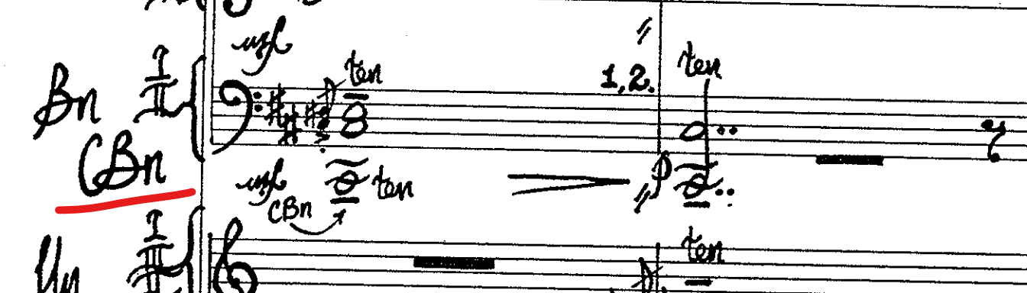 | Written!
Violas | 76 | 3rd beat E♯ or meant to be E♮? | E#
Viola | 79 | Beats 2 and 4, enharmonic instead? | No
CB | 91 | Rhythm/beaming correction. | Correct
Violin I | 108 | 3rd beat, since there is an accent on the A, can we remove the slur? | Remove the tie
Trumpets | 108-110 | Suggest swapping Tpt. 2 and 3 voices around for easier score reading. | No it's correct.
Violas | 110 | Added treble clef change to reduce ledger lines in original alto clef. Lasts for 2 bars. | Leave in score, part should stay alto
Picc. | 118 | Last beat, should staccato be removed? | Leave
Picc. | 121-129  182-183  195-198 | Solo violin playing. Remove piccolo passage?
Bassoon | 123 | Tenor clef for Bassoon to reduce the number of ledger lines. | Ok
Winds | 125 | 2nd beat, highly dissonant chord. E♭ in flute, E♮ on oboe, F♮ in bassoon. Is this intentional? | Yup
Violin I | 148 | Is this G♭ or G♮? | G natural
Violin I | 152 | Divisi or unis?  Slur is also very long, is it more gestural than technical? | Change to grace note and cut slur.
Harp 2 | 160 | What are the pitches for this harp glissando? Is it still in G♭ major? | Yup it is.
Violin I, II | 161 | Staccato tied notes? | Leave as is
VC | 183 | Tuplet within tuplet. | Yup but clean up
Violas | 193 | Possible F♮ clash with F♯? | No
Violas | 196 | Double stop string skipping in first beat, is it okay? | It's correct, B on D string not on A string so no string skip
Cymbal | 197 | Is this a suspended cymbal or crash cymbal? Seems like the notation has a sizzling effect. | Crash cymbal
Trumpets | 229-231 | Just to confirm, is bar 231 trumpet order 1, 2, 3? | It's 1 2 3
Percussion | 235 | Cymbals changed to half-beat and tremolo (3 lines instead of two).  The percussion is only three parts, but there are 4 parts here. | Ensure Tam-tam is on F (lower than bass drum)

Prevous Errata (version 0 - solo vn only)
Solo Vn | All | Wondering if the 'ten.' markings are redundant given the tenuto symbols. However, if it is a preference or the intention is for a more pronounced tenuto, let me know. If no preference, we could potentially remove them, except at key moments, and just ensure a tenuto symbol is present. | Leave as is ✓
 | 19 | Technically does the sul G continue from m. 19 till the F in m. 27? Will format accordingly | Yes ✓
 | 98-99 | Piece diminuendos back to f from a f. Should it dim. to a different dynamic, with a sub. f after? | Keep as is ✓
 | 110 | I extended the crescendo line - let me know if okay? | Works! ✓
 | 111 | Does meno mosso start at beat 1 of this bar or another beat? | Beat 1 ✓
 | 157-58 | Piece crescendos to f from f. Is this correct? | Keep as is ✓
 | 163 | Beat 4 - added a potential missing slur. Let me know if incorrect. | Add slur ✓
 | 182 | Rhythm is incorrect - did you mean this, or is the sextuplet a set of grace notes? | Change to grace note! ✓
 | 212 | Does the 8va start here, and is this tied to the next bar? | 212 is no 8va, slide up. ✓
 | 234 | Just want to confirm that you meant harmonic here? | Yes ✓

